Turn your Dreams into Reality

Home Design and Construction with Specifications at 1850*/ sq. ft.

Multiple Options in Specifications Stage wise Payment Plan inside



9910941701 | [www.zendenn.in](http://www.zendenn.in/) | mktarrowdesign.in

*This is an approximate price for stilt +3 or stilt + 4 floors configuration. Actual prices may vary.

## **Home Design & Interior Services**

Each Home is Designed Especially for You- We will Design and Build your Dream home Including Furniture and Soft Furnishings- TURN KEY!

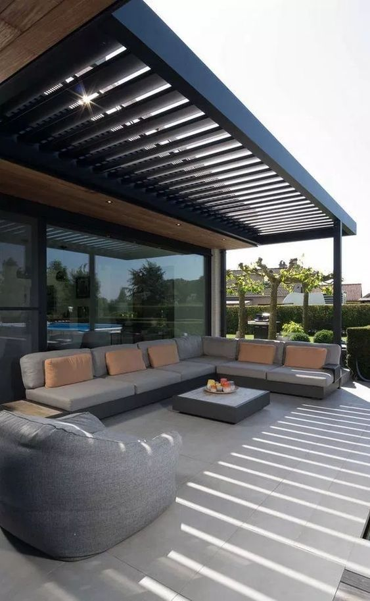

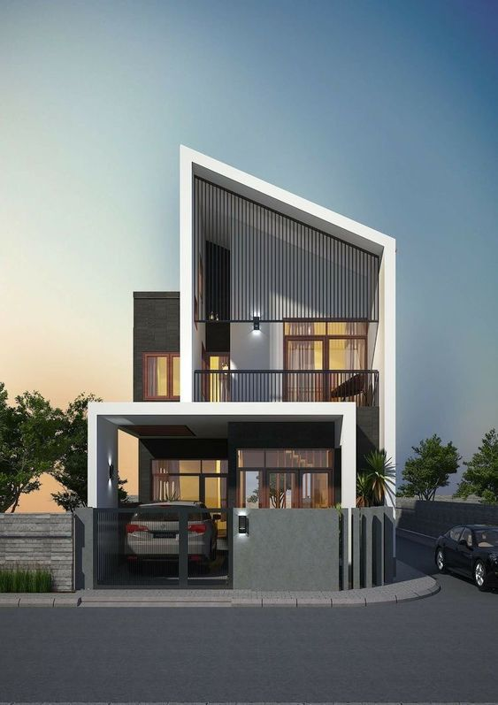

**3D Home Exterior Design**

Electrical, plumbing, AC & False Ceiling draeings

**Fully Customized Floor Plans**

Team of Experienced Award-WinningArchitects – Interior Designers – Structural Engineers – Civil Engineers and a highly experienced execution Team.

|  |  |
| --- | --- |
| Architectural | Floor plans, elevations, structural, electrical and plumbing drawings are included.Floor plans and elevations will be made by our team based on design brief developed in discussion with owners. |
| Structural | One or two concepts will be presented. For elevation, one 3D rendering will be shared. |
| Electrical & Plumbing Services | For material selection, we have catalogues and samples in our office. In case  the owner Wishes to visit the market for material selection, he will be  accompanied by our Project Architect once. |
| Design | For interiors - We give a presentation with reference images and Based on the  Feedback execution drawings will be redrawn and issued on site for work.  Out-of-scope work will be chargeable and the charges will be notified  Beforehand. |

## **Structure (** Robust Structures that Last for Generations )

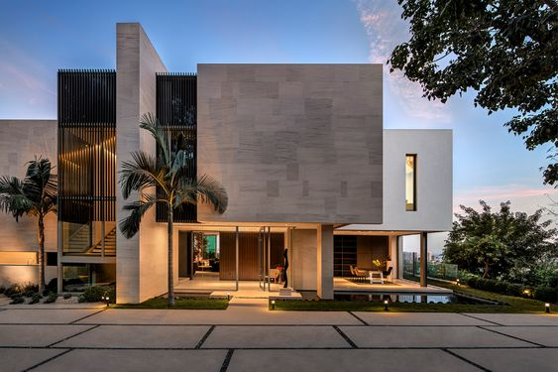

**Soil Testing before start of construction**

**All Construction as per IS Codes**

**Earthquake Resistant**

**Structures**

|  |  |
| --- | --- |
| Demolition of existing Structure (if any) | Any proceeds/income from the demolition will go to the owner. Period of demolition is not considered to be a part of the project timeline. If demolition is applicable, then an additional fee of Rs. 50,000/-(plus GST) will be charged.  If there is any damage to the neighbor’s home due to demolition, it will be Arrow Design’s responsibility.  (In case of seepage in neighbor’s home cost as per actuals) |
| Structure | We conduct soil testing and then design the structure. Structural load will be for the number of floors planned. Designed as per IS Codes and Earthquake Seismic Zone IV Complaint. |
| Excavation and Foundation | Done per IS Codes. |
| PCC | Used below Foundation, Stilt (if applicable), Terrace and for  leveling sunken areas. Also used to make platforms for fixed  wardrobes& cabinets in bedrooms and kitchen.  PCC will be done in the ratio of 1:4:8 |
| Concrete | Slabs and beams - RMC of M25 grade or as specified by  Structural Engineer.  Foundation and columns - Site-mix or RMC of M25 grade or as  Specified by Structural Engineer as per feasibility. |
| TMT Steel | Kamdhenu / Rathi / Kay2 - As per structural  Drawings in compliance with IS Codes. |
| Brickwork / Block work | A Class Bricks, - As per the IS codes and dimensions required by -Laws and drawings.  Fly Ash/Red Bricks |
| Plaster & POP | Cement-Sand plaster (1:5) used. Mesh is used on  Joints of walls and concrete to protect them from cracks. |
| Floor to floor height  (Including slab) | Upto 10 ft. , Tarai/Curing Compound used |

## Plumbin

## **gSerPlumbing Services**

Thought through Plumbing and Water Management

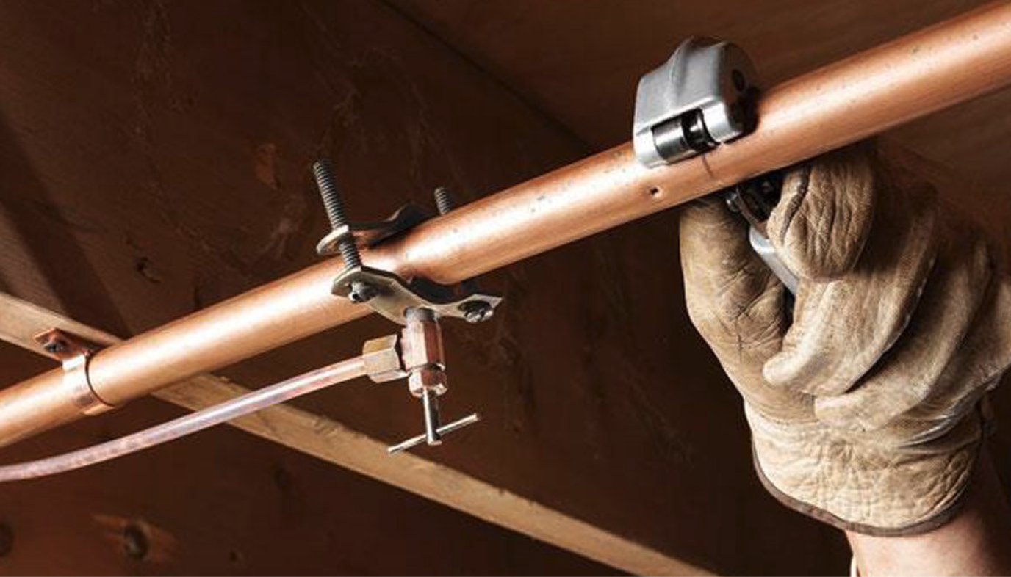

**Rainwater Harvesting System**

**Undergroung and Overground Water Tank for each Floor**

**Flexible Pipes**

**Which prevent seepage**

|  |  |
| --- | --- |
| Water meters | Provision for water-meters as per local law |
| Pipes | Fresh Water Supply: Kitec/Astral/Similar Composite pipes. Chances of seepage are reduced as the pipes are flexible and require less joints. Wastewater and Sewage: Astral / Finolex/Similar |
| Tanks | Underground Tanks: Construction done with commercial Tilling and waterproofing s ize of the underground Tank will be as per owner’s preference  But depth of structure will not be more than 1.5 meters.  Overhead Water Tanks: 1000 Litres Sintex/Similar Double layer tank  Per home. Placed on raised floor on terrace or mumty as per bye-laws. ( credIt Value Rs 6000/-tank ) |
| Rain water Harvesting | As per norms. |
| Taps | One tap with double outlet in service balcony, one tap in stilit connected to common tank,One tap on terrace connected to top floor. |
| Manholes, Catch-basins & Gully Traps | Covered by exposed iron covers. |
| Plumbing Design | Single-stack plumbing system design used. Piping is  Under slung for hygiene & comfortable. access. Slabs are partly sunken,  the pipes are camouflaged. |
| Rain Water Drain | Restoration / Construction in front of the house. |

## **Electrical Services**

Fire Safe Electrical Planning

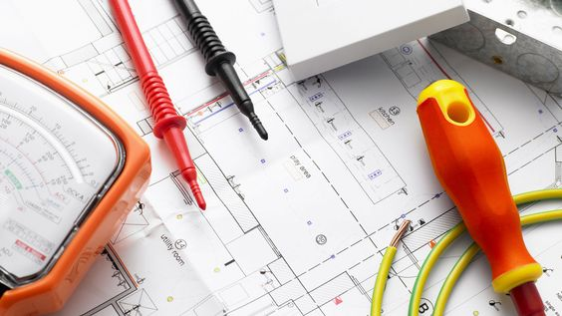

**Switches from Anchor/Norisys**

**Separate Conduits for Power , Light wires and AV circuits**

**Wire as per IS Code only**

|  |  |
| --- | --- |
| Electricity Meters | Provision as per local laws. |
| Connected Load Calculation | As per the Project Services Consultant |
| Inverter | Provisioning only for all light, fan and 6 amp points. |
| Electrical Wires and Circuitry | |  | | --- | | Wires: Fire-resistant low smoke wires (copper core) from Havells / | | Finolex Anchor / KEI/Polycab/Tamra/Similar Main Panel to | | Distribution Board: 10 sq mm wires | | Light circuit: 1.5 sq mm wires Power circuits: 4 sq mm wires | | AC: 2.5 sq mm wires, 4 core wires Light points, Earthing: 1 sq mm wires | | | Power points, Geysers: 2.5 sq mm wires | | | TV / Telephone / Internet: Internal wiring done | |   . |
| Conduits | ISI certified conducts |
| Earthing pit | As per services design |
| Switches | Anchor Roma/Urban in white colour ( in the starting range ) |
| MCBs, ELCBs &DistributionBoard | Havells / Anchor/L&T |

## **Other Essential Services**

Hassle-Free Living during and after Construction

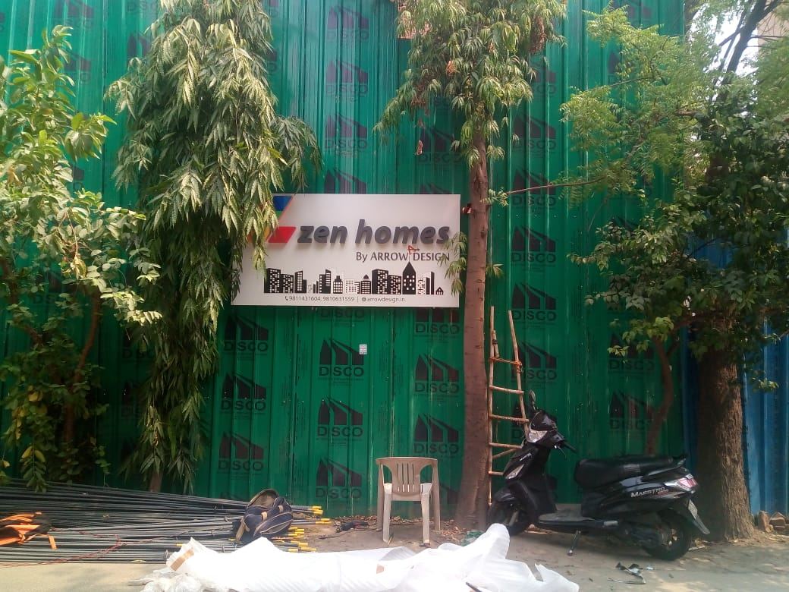

**Waterproofing by Dr. Fixit/Similar**

**Anti-termite treatment**

**Provisioning for Air Conditioners**

|  |  |
| --- | --- |
| Site barricading | Site and building barricading as per the rules. |
| Waterproofing | Dr. Fixit/Asian/Similar - On terrace, bathroom, mumty and underground water tanks.  On terrace, bathrooms and mumty waterproofing is done on floor and upto 1.5 ft on  walls. |
| Provisioning for Air Conditioners | copper pipes of 1/2 and 1/4 to ensure compatibility with 10 mm insulation and  3-core wire of 2.5 sq. mm thickness. |
| Anti termite treatment | Done at plinth level with Bayer/Similar anti-termite chemical. |
| Water and electricity bill during construction | Monthly recurring bills are paid by owner from the day of handover of plot to the day of delivery. Any one time non-recurring fee or security deposit has to be paid by the owner. |
| Approvathls | All approvals regarding home construction are taken care of by Arrow Design which include Water and Electricity approvals along with submission of Labor cess and Completion fee( Which is to be Paid by The Owner). Arrow Design will handle the efforts but all official and out-of-pocket expenses will have to be borne by the Owner on actual basis. |
| Lift / Lift Shaft | Done as per structural drawing & lift requirement. (lift up gradation Credit value of  Rs. 7,00,000/-) |

# Flooring

### Beautiful Flooring options for premium looking homes

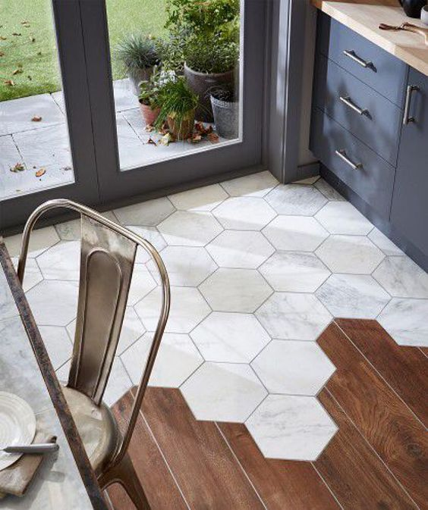

Granite Counters in Kitchen and Bathroom

Granite on

stilt / parking area

Internal Flooring with

Kajaria Tiles 2x 4

|  |  |
| --- | --- |
| Internal Flooring | Wooden Flooring (pergo AC3 series or Action Tesa ) in half of the bedroom and Glazed vitrified tiles from Kajaria in rest of the house.( credit Value: Rs. 125/- sqft of flooring and skirting area) |
| Skirting | 4" high wood/Tile skirting to match flooring in the space |
| Bathroom (Floor +Walls) &  kitchen walls | Anti skid Tiles/Glazed Tiles installed upto 2 ft above the counter area, bathroom tiles will be installed till door level. |
| Balcony | Vitrified Tiles |
| Staircase, stilit and open area (Tread , riser & skirting) | Granite (uptoRs. 90/ sq. ft.) from Arrow Design's catalogue |
| Terrace flooring | Vitrified Tiles uptp Rs 50 sqft. |
| Kitchen and bathroom counter | Granite of up to Rs. 200/ sq. ft. |
| Toilet on stilt, Terrace & Servant Room | Commercial tiles |

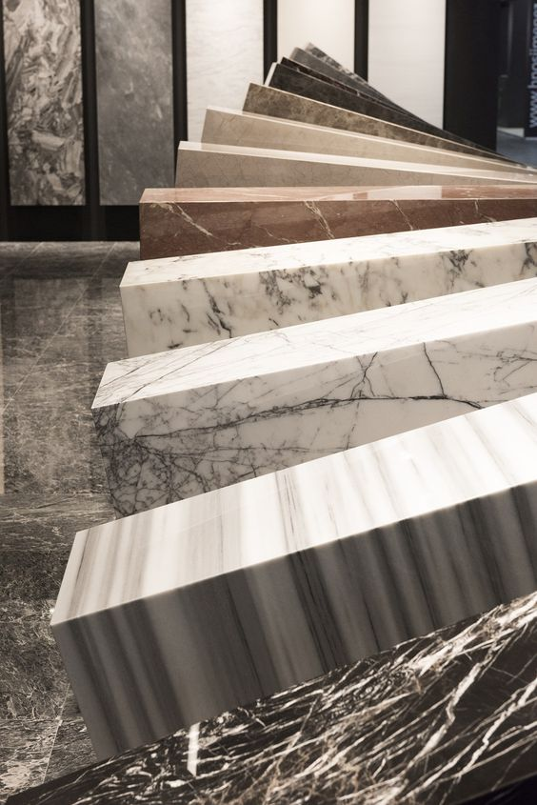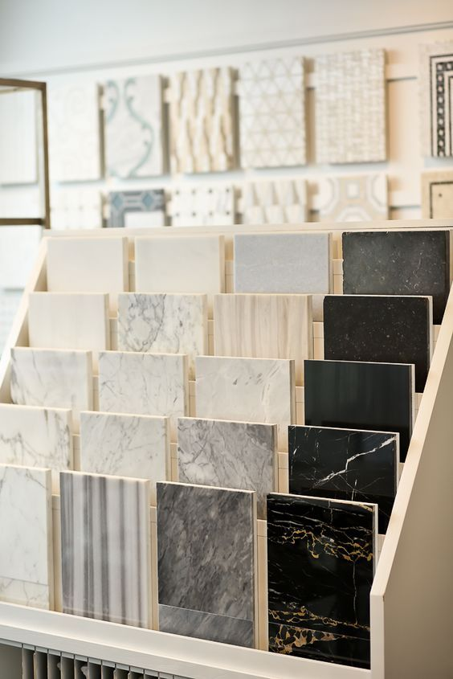

**Upgrade to Italian Marble**

**Options:**

Bottocino

Perlato Wave

Safari Beige

Perlato Sicilia

Tivoli Beige

Elmali Beige

Sofia Beige

Perlato De Martino

CremaAtlantico

CremaExtralite and among others

**Kitchen**

**Good Aesthetics with functionality**

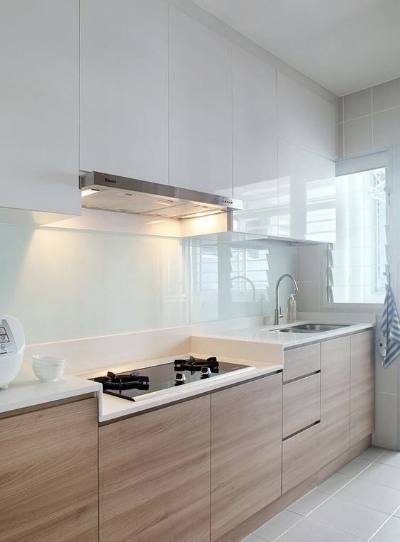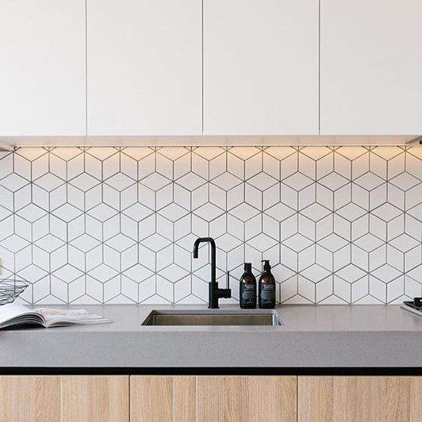

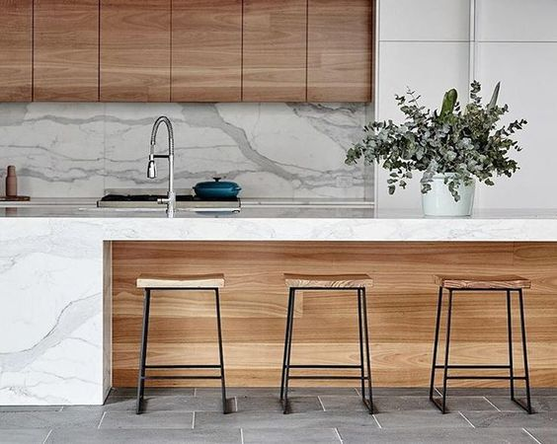

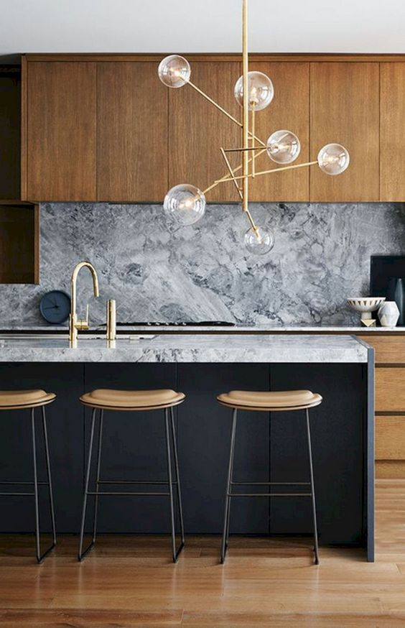

|  |  |
| --- | --- |
| Kitchen | Factory made and fitted Modular kitchen with Hob and Chimney. (Credit Value 2,25,000 per kitchen) |
| Tap and sink | Sink and faucet (credit value of Rs.13, 000 per kitchen) |

**Doors**

**Strong Doors with Premium Hardware**

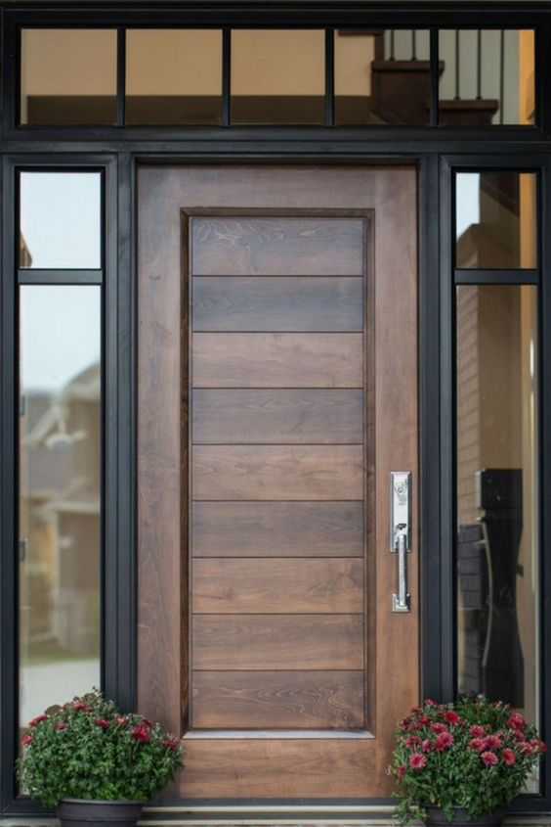

Flush Doors

Hardware from Dorset/Similar

**e**

|  |  |
| --- | --- |
| Main Door  ( For each apartment and stilt) | Opening Size: Upto 4'-0" wide x 7'-6" high door  Door and Frame : Factory Made pre- laminated Flush Doors & frames from Sumai Mikaas ( Green ply ). |
| Internal door | **Size**: Upto 3'-6" wide x 7'-6" high door For Bedrooms, Store / Puja room etc. and upto 3’ wide 7'-6" high door for Bathrooms  **Door frames**: Factory Made pre-laminated engineered doors & frames from Sumai/Mikasa (Green lam)  **Hardware**: Cylindrical lockset handles with budget up to Rs 1000, hinges, bolts, buffer &doorstop selected from Dorset/Similar.  No of doors: One in each bedroom & bathroom. |
| Door Upgradation | Credit value of Rs. 20,000/-( GST included)for internal & main door will be provided per door ( including hardware & installation) in case the owner wants to upgrade the doors. |
| Special  Internal Doors | Special internal doors like sliding,folding, glass dors, Kitchen doors, Puja/Store room doors are charged separately as per design. |
| Service and servant room doors, toilet | Aluminum door and frame with WPC paneling provided at stilt level  for access to service lane, on terrace and servant rooms |

**Wardrobes**

**Study Wardrobes available in multiple finishes**

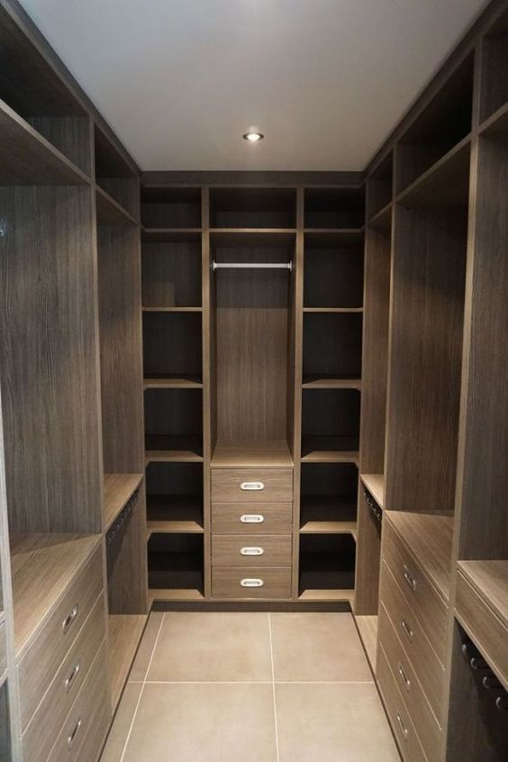

|  |  |
| --- | --- |
| Wardrobes | Pre-laminated factory made wardrobes of 6 ft by 7 ft with one drawer in each bedroom, (credit value Rs. 1250 Sqft)  A vanity below the wash basin counter in each bathroom in laminate finish with the open shelves.  Approx area of 4 qft (credit value Rs. 5000/-sqft) |

**Windows**

**Large Windows for Maximum Natural Light**

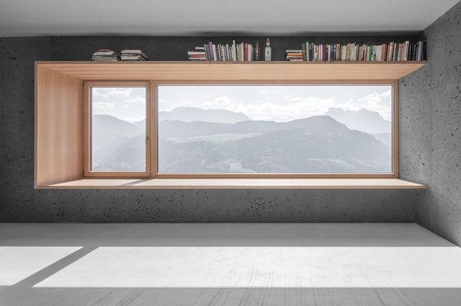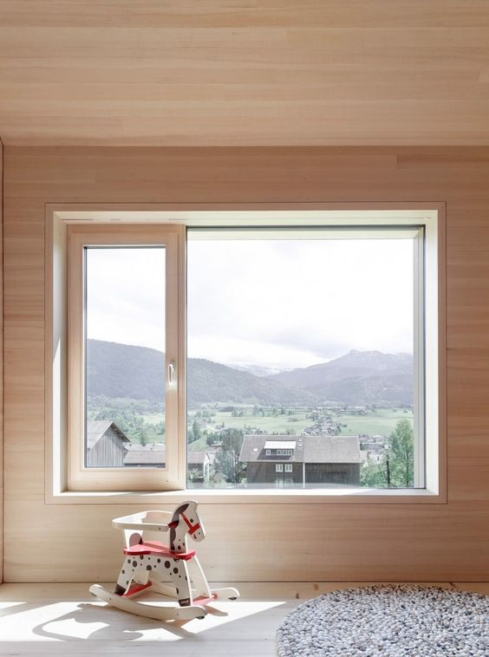

**Large windows, which allow maximum natural light**

Windows with Mosquito Mesh

Single glazed UPVC- Windows

|  |
| --- |
| WINDOWS (IN BEDROOMS, KITCHEN & LIVING ROOMS, SHAFTS/COURTYARDS) |

|  |  |
| --- | --- |
| Material | Single glazed UPVC Windows with toughened glass (Credit value Rs 650/-)  All windows in the house are included except basement,  Total area of windows in the home, not to exceed 12% of  the covered area. |
| Design | If opening is more than 3' wide - 7' high combination of fixed and open able window/ door  Sliding windows are with bug mesh. |

**Fittings and Fixtures**

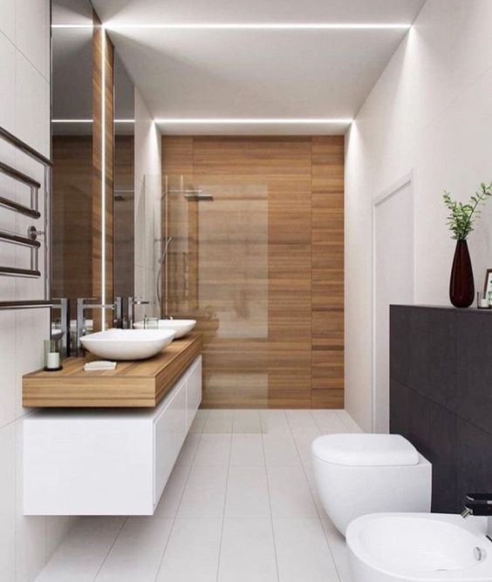**Add Elegance to your Home with Premium Fittings and Fixtures**

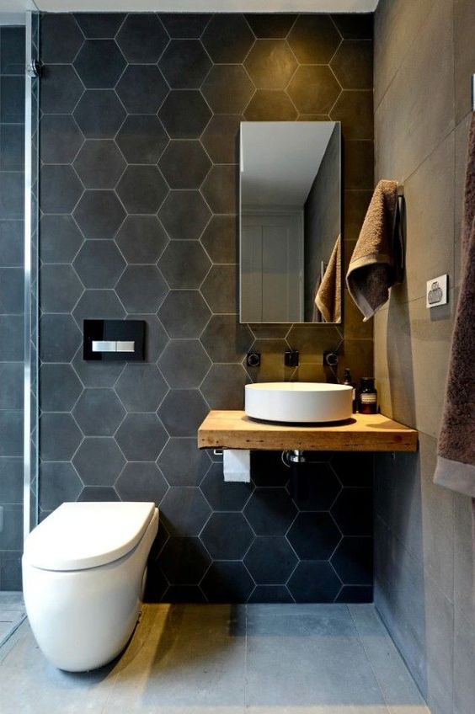

|  |
| --- |
| BATHROOMS |

|  |  |
| --- | --- |
| Design | 3 fixture Bathrooms (Basin, WC and Shower area) |
| Wash Basin, WC and Shower fixtures | Full bathroom consisting Kohlar/ Jaquar?Grohe?Hindware  Fittings. Budget of Rs. 35,000 (MRP) per bathroom, Credit  Value for powder room – Rs. 20,000/- per habitable floors ) |
| Bathroom Concept | Niches with provisioning for light and finished in tiles used in bathroom.  Frameless float glass mirror as per design. ( credit value of Rs.  2000 Per bathroom) |
| Bathroom on Stilt, terrace or servant room on  habitable floor | Credit value of Rs. 14,000/- per bathroom |
| Geyser Provisioning | When bathroom is next to balcony: Outside in balcony or inside as per owner's preference When bathroom is not next to balcony: Inside bathroom |

**Finishing**

**Elegant, Stylish & Sophisticated Finishes**

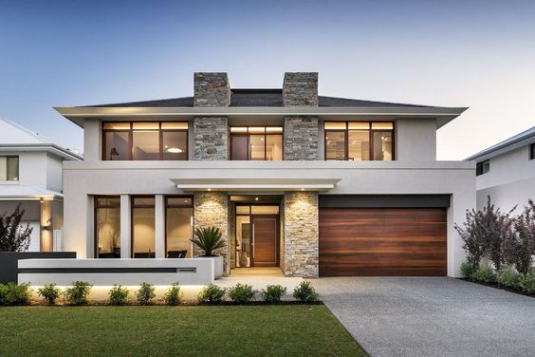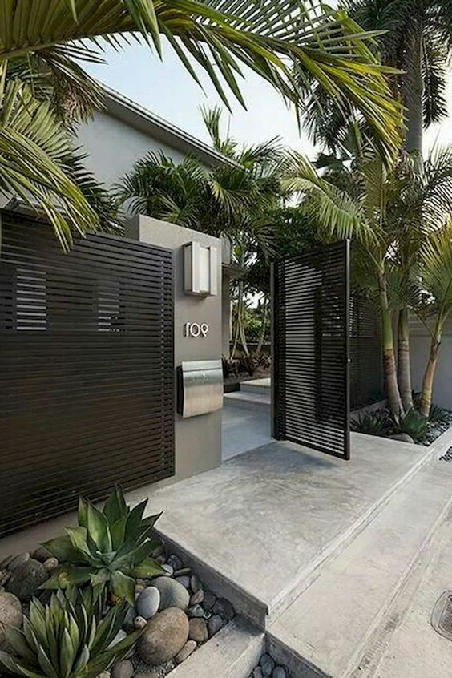

Luxury Emulsions from Asian Paints / Berger / Nerolac

Extensive list of materials

for Facade Design

**Cove in rooms and False ceilings in bathrooms**

|  |  |
| --- | --- |
| FAÇADE DESIGN / ELEVATION (*BRANDS WE USE*) | |
| Façade design  (Including boundary wall) | Plain Plaster with Apex Paint. (Credit value of Rs. 50-/ sqft) and MS railing (credit value of Rs. 600 per running feet) installed on balcony toe wall finished with granite used in stilt. Stone cladding, glass railings, HPLSS railing, cornice etc. can be incorporated at additional cost. In case of plot with more than one side elevation cost will be extra. |
| Boundary Wall & Gate | Gate design in MS with enamel paint . Gate columns cladded in granite used in stilt flooring. (Credit Valueof Rs. 50,000/-) |
| Name plate | Plot No. in steel alphabets and name plates in steel with etching ( credit value of Rs. 20,000/- |
| Lift Lobby | Finished with a band of 12 inch granite |
| Neighbors Wall | Uncovered wall towards the neighbor’s house will be plaster finished by Snowcem. And will be separately chargeable. |
| WALLS & CEILINGS | |
| Internal Walls Finish | Luxury/ Premium Emulsions from Asian Paints / Nerolac / Berger |
| External Walls, Stilt, Terrace, Balcony | Apex ultima with from Asian Paints or ICI |
| Decorative false ceiling | 6-inch cove made with provision for strip lights in living/dining area & all bedrooms. False ceiling in bathrooms. ( credit value Rs. 80/-sqft of the board area ) |
| FABRICATION | |
| Staircase Railing | MS Railing with enamel paint from Asian Paints (Rs. 600per running feet ) value |

## 

**Basement**

**Add more Charm and Functionality with Basement**

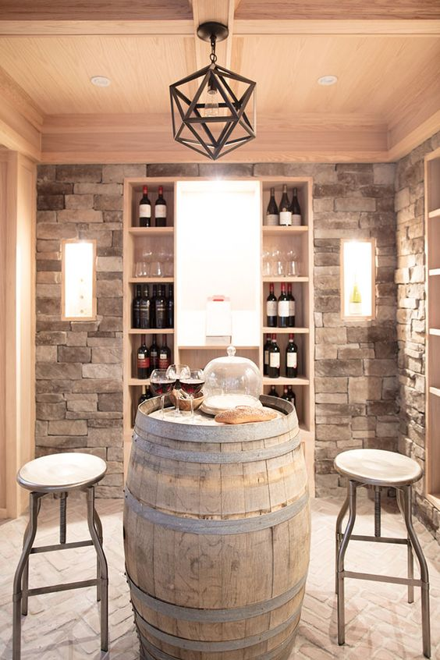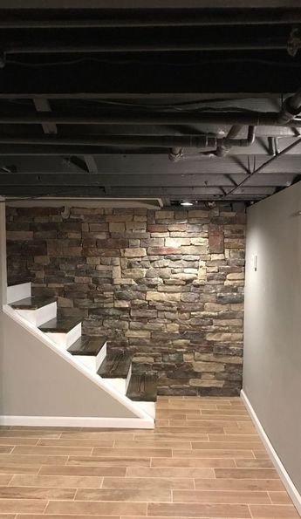

**Glazed Virtified tiles**

**fromKarjaria**

Construction strictly as per IS Codes

Waterproofing on all 4 sides and floor

|  |  |
| --- | --- |
| Side walls | Concrete retaining walls complying to IS Codes and structural  Drawings |
| Waterproofing | On all 4 sides and floor |
| Proper Drainage and Sewerage with Sump Pit (If Applicable) | Yes |
| Internal partitions/ walls | As per bylaws & drawings |
| Toilet | Yes, as per bye-laws |
| AC | Provisioning only, ie complete copper piping, drain pipe layout and 16Amp point with 1.5sqmm wire, for AC will be done |
| Paint | Luxury / Premium Emulsions from Asian Paints / Berger / Nerolac |
| Door | Size: Upto 3'-6" wide x 7'-6" high door  Door frames: Pre Laminated Factory Made Doors. One Doorprovided at entry to basement.  Hardware : lockset handles, hinges, bolts, buffer & doorstop  selected credit value of Rs. 1000/- |
| False Ceiling | Not included |
| Flooring | Glazed vitrified tiles from Kajaria |

**Cost Breakup**

**Covered Area at 2360*/ sq. ft.**

**Half-Covered Area at 1500*/ sq. ft.**

**Basement at 2050*/ sq. ft.**

**Open Area at 510*/ sq. ft.**

*The cost increases by 7% if total built up area is less than 6500 sq. ft.

*Cost of inclusive of GST

*Arrow Design reserves the right to change the costs & specifications without any prior notice.

**Definitions**

**Covered Area:**

Area covered from four sides with a roof.

For example, habitable area, staircase, lift shaft,

Under-ground water tanks, mumty, servant room, etc.

**Half Covered Area:**

Balconies, Stilt and Sunken Courtyards.

**Open Area:**

Courtyards, Setback and Shafts areas open to sky. Shafts with area less than 50 sq. ft. will becounted on each floor.

Basement :-

Basement area including retaining walls and staircase, lift, shaft, lift Lobby.

Additional information.-

1. Post CC work is not included in this document.
2. Crecit value( where ever mentiond in the document ) will be provided in case of change in areaor change in specification. The credit value is inclusive of GST.

# Easy Upgrades

### Don’t leave any work for the future. Upgrade to complete all finishing’s.

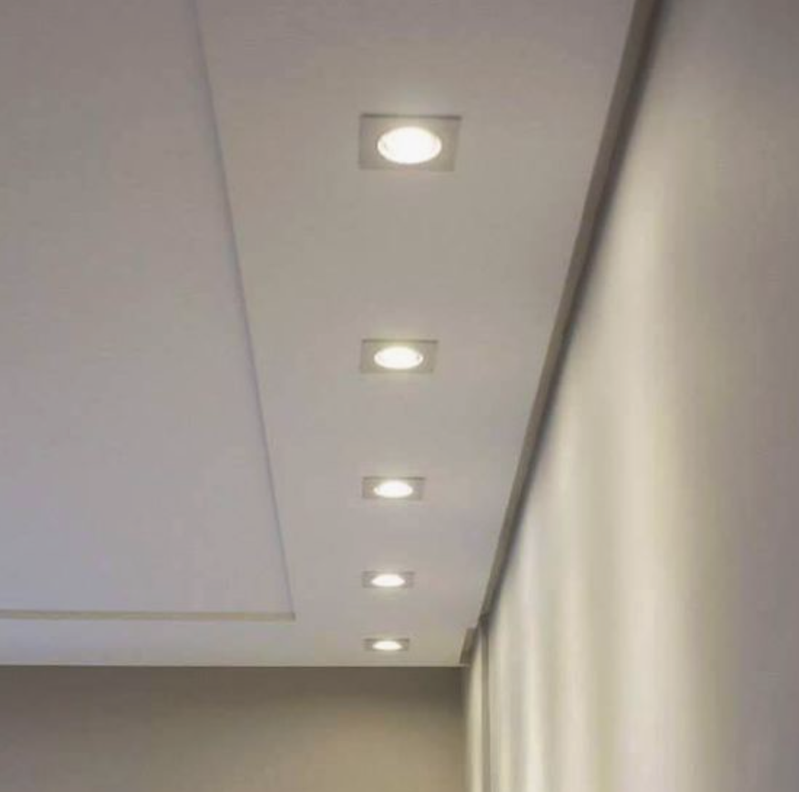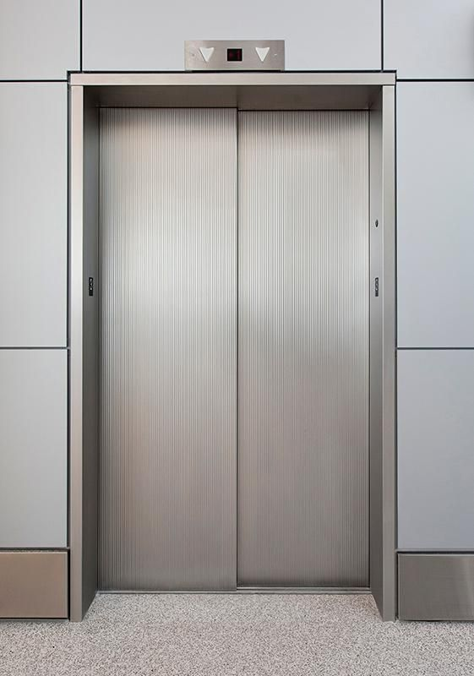

|  |  |
| --- | --- |
| Lights, Fans, ACs and other appliances | For a true Hassle-Free home building experience you can opt for  electricals such as Lights, Fans, Air-Conditioners, Geysers, Motors, Video Door Phone, Motion Sensors, CCTV, etc. with Arrow Design. |
| Lift | Lift from Schindler / Otis / Kone in metallic finish and push buttons with Automatic Rescue Device. |
| Interior Concepts | We can work according to the interior concepts you have in mind. The same can be finalized with our architects. Finishing’s can be done accordingly and can include LCD Panels, decorative walls &  Ceilings, along with other ideas which you might have. |

**Pricing, Payment****/Project Schedule**

**( For a typical Stilit+4 Floors configuration)**

**Tentative Schedule**

**Payment**

**Milestones**

**Milestone Definition**

|  |  |  |  |  |
| --- | --- | --- | --- | --- |
| 1. | **Contract Signing** | **1%** |  | Signing of 'Turnkey Contract ‘between plot owner and Arrow  Design Homes |
| 2. | **Floor Plan Sign-off** | **2%** | Within 45 days of contract signing | Finalization of Floor plan between plot owner and Arrow Design |
| 3. | **Handover of Plot** | **0%** |  | Plot Handover for start of demolition/construction will be taken after receipt of sanctioned plan approvals. If demolition is not applicable then this milestone is merged with milestone 4. |
| 4. | **Start of construction** | **4%** | Day 0 | After completion of demolition (if applicable) and GFC-1 set on site. |
| 5. | **Start of Each Slab** | **38%**  (divided equally  over number of  slabs) | Month 2-5 | Start of column erection for each floor |
| 6. | **Start of Brickwork** | **5%** | Month 4 | 1st day of brick/block laying on project site |
| 7. | **Start of Services**  **(AC Plumbing, Electrical)** | **10%** | Month 5 | 1st day of work commencement  on site for either of the services mentioned |
| 8. | **Start of Flooring** | **10%** | Month 7 | On placement of order of flooring material onsites |
| 9. | **Start of Woodwork**  **(Door, window)** | **10%** | Month 8 | On placement of order for woodwork  (wood may arrive at stages foreasier storage) |
| 10. | **Start of Finishing** | **10%** | Month 10 | 1st day of delivery of paint at  sites (all paint might not be  delivered to site on 1st day itself) |
| 11. | **Start of Fitting & Fixtures** | **5%** | Month 11 | 1st day of delivery of Bathroom Fixtures on  sites |
| 12. | **Invitation for Handover & Completion Certificate** | **5%** | Month 14 | Actual Handover with warranty,certificates,  legal papers etc |

* **All Government Fees and Taxes areExtra**